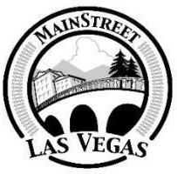

Press Release

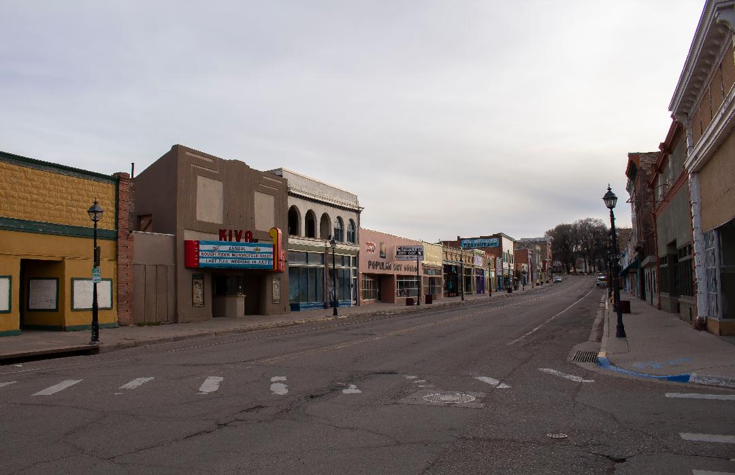

MainStreet de Las Vegas presents a community forum:

What Happens Next? How small businesses in Las Vegas will survive when the money runs out
For Immediate Release: May 21, 2020
When: Thursday, May 28th at 1:00 on Zoom
For information please contact: Michael Peranteau/505.617.6800

MainStreet de Las Vegas (MSLV) will present a community forum that will focus on the survival of small businesses in Las Vegas during and after the Pandemic. Many small businesses received funding from the federal government through its Payroll Protection Program (PPP), Economic Injury Disaster Loan (EIDL) and enhanced unemployment. This forum will focus on ways to help these businesses survive and thrive when this funding runs out over the next few months. It’s a unique and complicated situation that we have never experienced before. This meeting will be the first in a series of community gatherings geared to help small businesses cope.
Panelists include Briana Montaño-Baca, Luna Community College's Small Business Development Center Associate Director; Allan Affeldt, hotel owner and Member of the Governor’s Economic Recovery Council; Sean O’Shea, Business and Entrepreneur Development Specialist with New Mexico Main Street; Sara Jo Matthews, owner of Borracho’s Bar and co-founder of the Vegabonds; and Bill Hendrickson, the new Community Development Director for the City of Las Vegas.
The mission of MainStreet de Las Vegas is to unify the historic commercial corridor and engender pride in the community while promoting economic development and preserving historical, cultural, architectural, and natural resources through partnerships and community collaboration.
Our vision is to help create a unique and vital downtown that supports our business community, embraces history, celebrates the arts, preserves our natural environment and promotes quality events to instill a ‘sense of place’ in our community. Downtown Las Vegas, New Mexico will continue to grow and develop as a result of continued support from our volunteers, local businesses, partnering organizations and our sponsors. MSLV is a program of New Mexico Main Street and Main Street America.

A Zoom link will be posted for this event on Wednesday, May 27th on MSLV’s Facebook page: https://www.facebook.com/MainStreet-de-Las-Vegas-131378056921408/

A strong downtown is an essential component to the integrity of a community.
